# **Experiment**

The first stage of our experimental work is the analysis of an electrical network in order to obtain the necessary electrical signals. Thus, a real three-phase power grid, consisting of two main stations, a source station and a distribution station was analyzed. The network analysis system consists of three high frequency current transformer sensors and one acquisition board. The configuration can be seen in Fig.1.

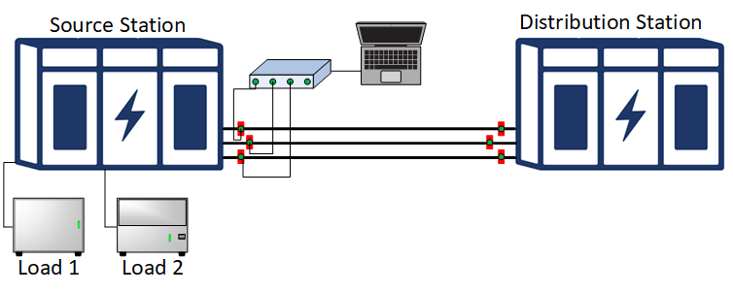

The experimental benchmark

The signals from the source station are analyzed. As expected, the analysis of the cable from the source station highlights several transients carried in the network. Fig. 2 shows the signal recorded at a sampling frequency equal to. Three different types of transients can be distinguished, specific to three generating sources.

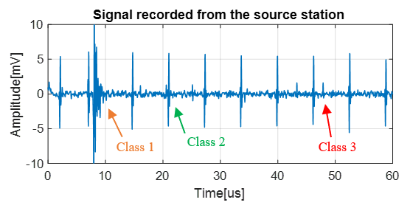

The signal recorded from source station

As it can be seen in Fig.3, the three transient signals have a specific shape.



The three classes of transient signals

Thus, you have at your disposal 3 classes of signals "cls1", "cls2", "cls3". Class 1 contains 68 signals of size 61 samples, Class 2 contains 482 signals of size 61 and Class32 contains 310 signals of size 61 samples.